 | Year 12 Specialist  TEST 1  Friday 9 February 2018  TIME: 5 mins reading 40 minutes working Classpads allowed!  37 marks 7 Questions

Name:_______________________________

Teacher: ____________________________

Note: All part questions worth more than 2 marks require working to obtain full marks.
Some useful Formulae
Note: All part questions worth more than 2 marks require working to obtain full marks.

Q1) ( 2, 2, 2, 2 & 1 = 9 marks)
If and determine exactly:

- What do you notice about (c) and (d)?

Q2 ( 2 & 2 = 4 marks)
Express each of the following into Cartesian form,

- 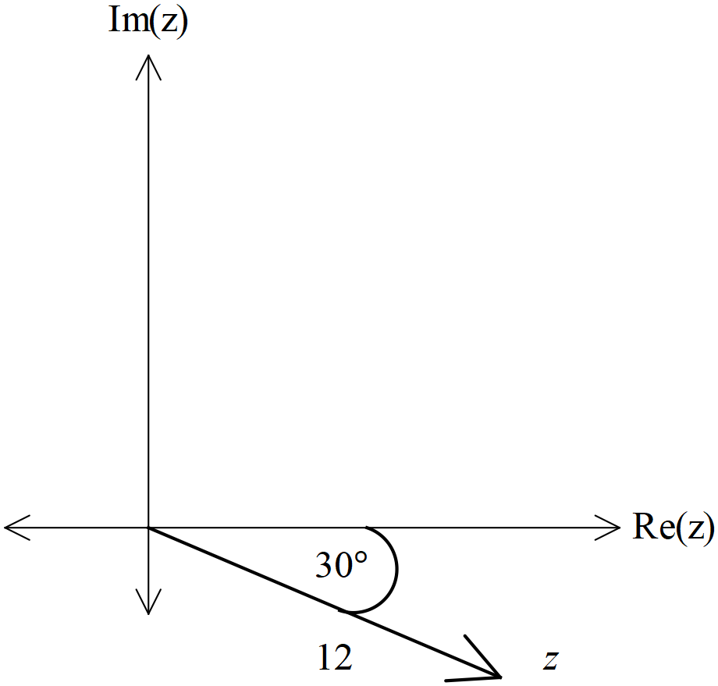

Q4 (3 marks)
Determine z in polar form given that w and zw have been drawn below.

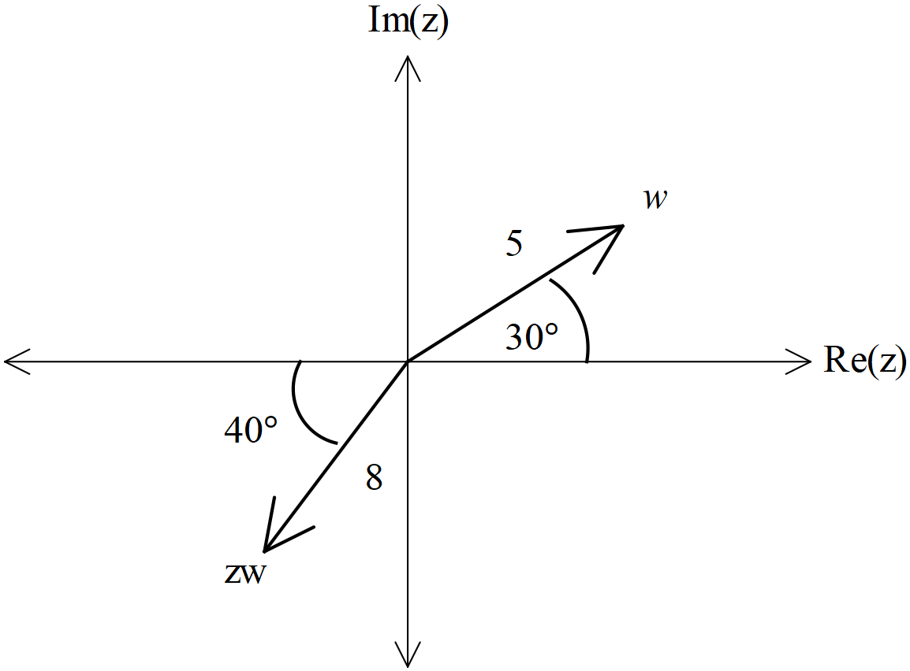

Q5 ( 5, 3 & 3 =11 marks)
- Determine all the roots of the equation , expressing them all in polar form with and

- Plot the roots on the diagram below. (Note: each minor angle is radians.)

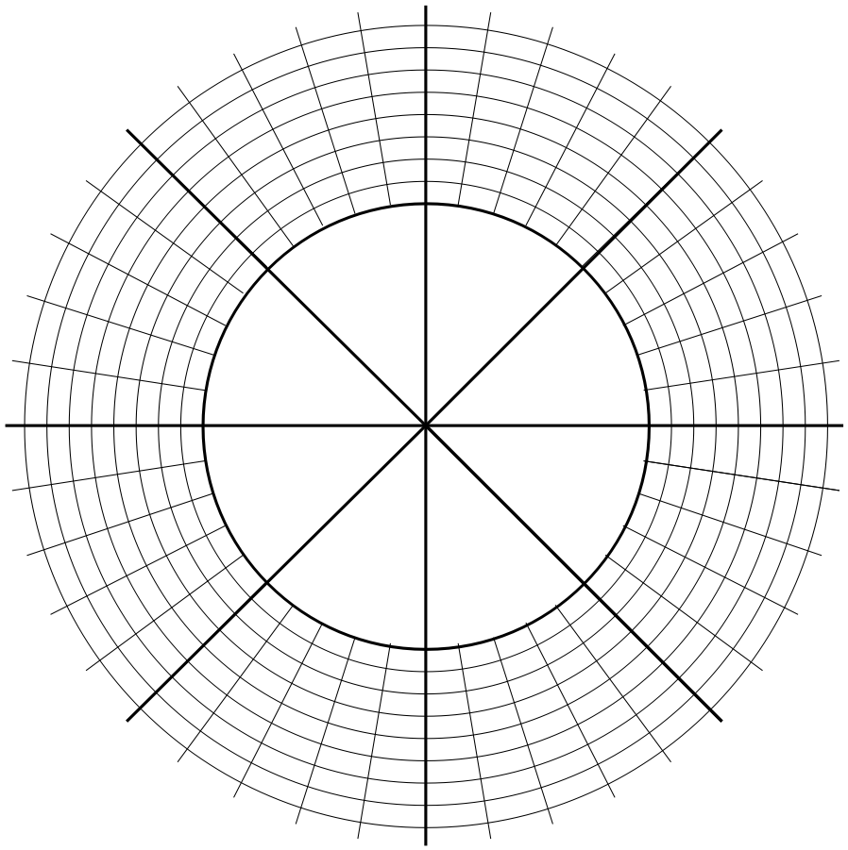

- The roots form the vertices of a pentagon. Determine the value for the perimeter of the pentagon to two decimal places.

Q6 (5 marks)
Determine, using de Moivre’s theorem, an expression for in terms of only.
{Hint: start with }

Q7 (5 marks)
Consider the points A and B in the complex plane. The perpendicular bisector of the line AB is represented by
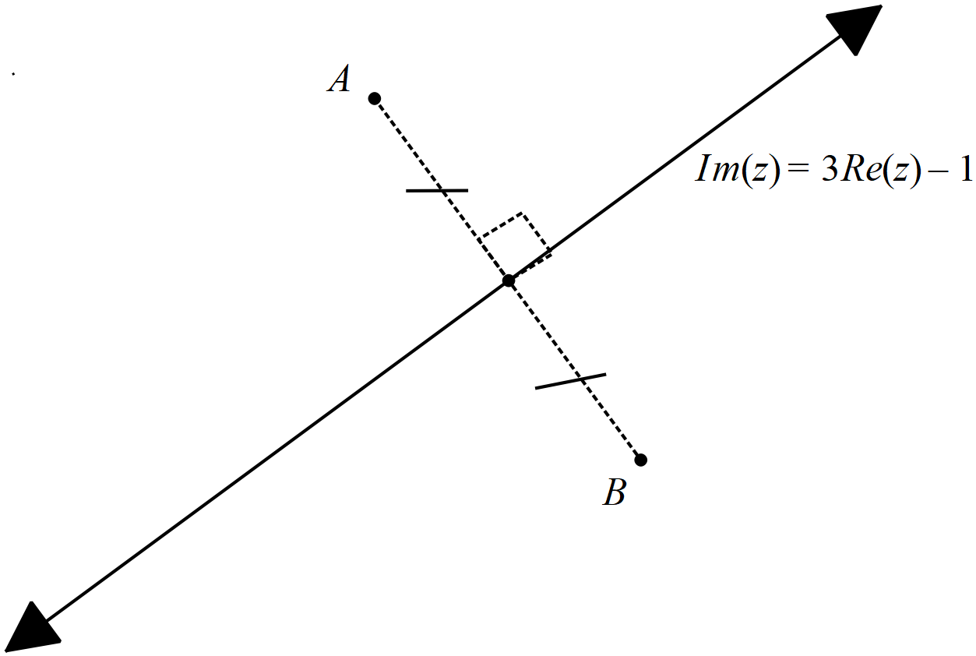

If point A is and point B is in the complex plane, determine the values of the constants c and d.

